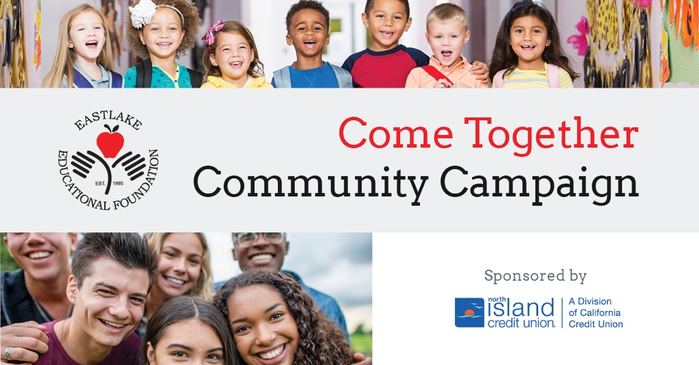

- What is the Come Together Campaign?

A fundraising campaign to raise money to fund technology hardware (computers, devices) Educational software (to teach core subjects and advance learning through online platforms) Professional Development (so teachers can have the training for advance their skills) and STEAM programs (Science, Technology, Engineering, Arts, and Math).

100% of the money raised will go to 7 Eastlake schools: Eastlake High, Eastlake Middle, Eastlake Elementary, Salt Creek Elementary, Olympic View Elementary, Thrugood Marshall Elementary, and Arroy0 Vista K-8 Public Charter School.

- How did the event go last year?
https://issuu.com/printandmailexperts/docs/eastlake

- Who should we ask to donate? Your personal business associates, those associated with the school.

- What will businesses get if they donate?
See Sponsor benefits handout

- How do people donate?
eefkids.org

- How will we get the word out?

November 9
PeachJar
Personal invitation to give
Fun contest
Principals /PTSA/Teacher custom message to the community
Banners up at school
Message on electronic banner
Share on social media
Yard signs throughout school
November 16
Personal appeals
- Key Dates
November 9, 2021- soft kick-off
November 16, 2021- public kick off with Impact Video and live speakers
November 30, 2021- Giving Tuesday push
December 15, 2021- live interviews
December 31, 2021- End of year appeal
January 15, 2022- New Year appeal
January 31, 2022-
February – TBD
Special Live interviews will happen as sponsors and donors pledge to the campaign

